Jean-François Quénard, Anne Sophie, Roussette de Savoie 2015
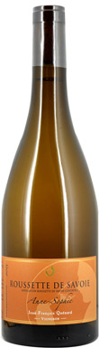
Tasted by Andrew Jefford(at Savoie, 26 Jan 2018)Part of Jefford on Monday: Savoie – the hunt for greatness
91
This Altesse is grown in the limestones of the Chignin alongside Quénard’s Roussanne. Half has blocked malo and is aged in tank, while the other half goes through malo and is aged in Stockinger casks. It’s full gold in colour, with a scent of warm peaches and soft candle wax. The rich, warm, chewy style conveys the impression of a wine that's bigger than itself - it seems sweet yet is fully dry, and it seems warm yet is just 12.5%. Lemon-plum acidity keeps the wine fresh, too. This is a generous Combe de Savoie rendering of Altesse. This, by the way, is the only one of the many ‘Quenard’ domains to spell its name with an accent.
Drinking Window 2018 - 2022
Producer Jean-François Quénard
Vintage 2015
Wine Type Still
Colour White
Country France
Region Savoie
Appellation Roussette de Savoie
Sweetness Dry
Closure Cork
Alcohol 12.50%
Body Medium
Oak Lightly Oaked
Grapes Altesse

